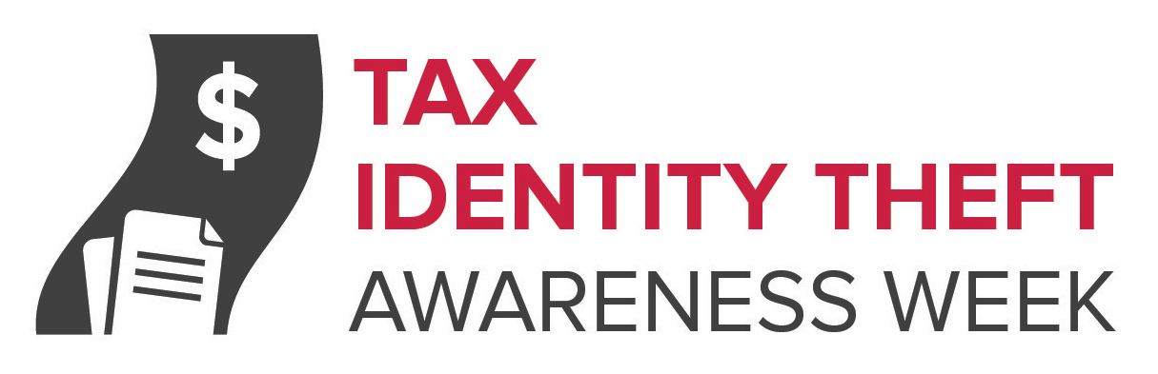

IRS Imposters Targeting Taxpayers

Tax season may just be getting started, but tax scammers have been hard at work. In fact, the Federal Trade Commission (FTC) has gotten thousands of complaints about one kind of scammer in particular — IRS imposters.

Here’s how they work: scammers posing as IRS officials call and say you owe taxes. They threaten to arrest or deport you, revoke your license, or even shut down your business if you don’t pay right away. They may know your Social Security number — or at least the last four digits of it — making you think it really is the IRS calling. They also can rig caller ID to make it look like the call is coming from Washington, DC.

Before you can check out the callers, you’re told to put the money on a prepaid debit card and tell them the number — something no government agency would ask you to do. Once you do it, you find out it was a scam, and the money is gone.
If you owe — or think you owe — federal taxes, call the IRS at 800-829-1040 or go to irs.gov. IRS workers can help you with your payment questions. The IRS doesn’t ask people to pay with prepaid debit cards or wire transfers, and doesn’t ask for credit card numbers over the phone. When the IRS contacts people about unpaid taxes, they usually do it by mail, not by phone.
Report IRS imposter scams to the Treasury Inspector General for Tax Administration (TIGTA) online or at 800-366-4484, and to the FTC at ftc.gov/complaint.
Speaking of tax scams, this is Tax Identity Theft Awareness Week. Tax identity theft happens when someone files a phony tax return using your personal information — like your Social Security number — to get a tax refund from the IRS. It also can happen when someone uses your Social Security number to get a job or claims your child as a dependent on a tax return. Tax identity theft is the most common form of identity theft reported to the FTC.

Tax identity theft victims typically find out about the crime when they get a letter from the IRS saying that more than one tax return was filed in their name, or IRS records show they received wages from an employer they don’t know. If you get a letter like this, don’t panic. Contact the IRS Identity Protection Specialized Unit at 1-800-908-4490. Learn more at ftc.gov/taxidtheft.

[YOUR ORGANIZATION’S INFORMATION]

