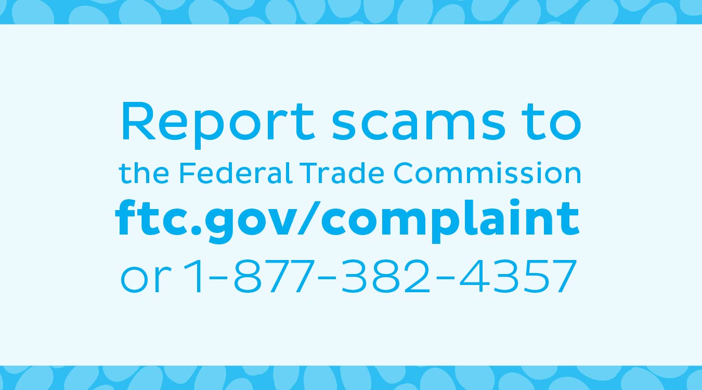

Why report scams?
Because your report can help protect people you care about. It can help the FTC shut down scammers, and can help others from getting scammed.

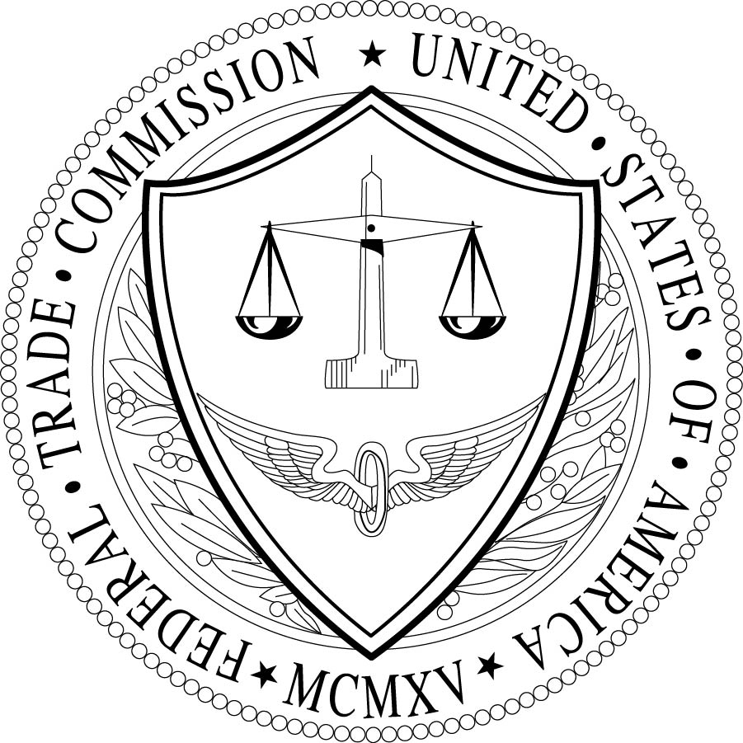
Federal Trade Commission
consumer.gov
July 2015

Produced in cooperation with the International Rescue Committee.

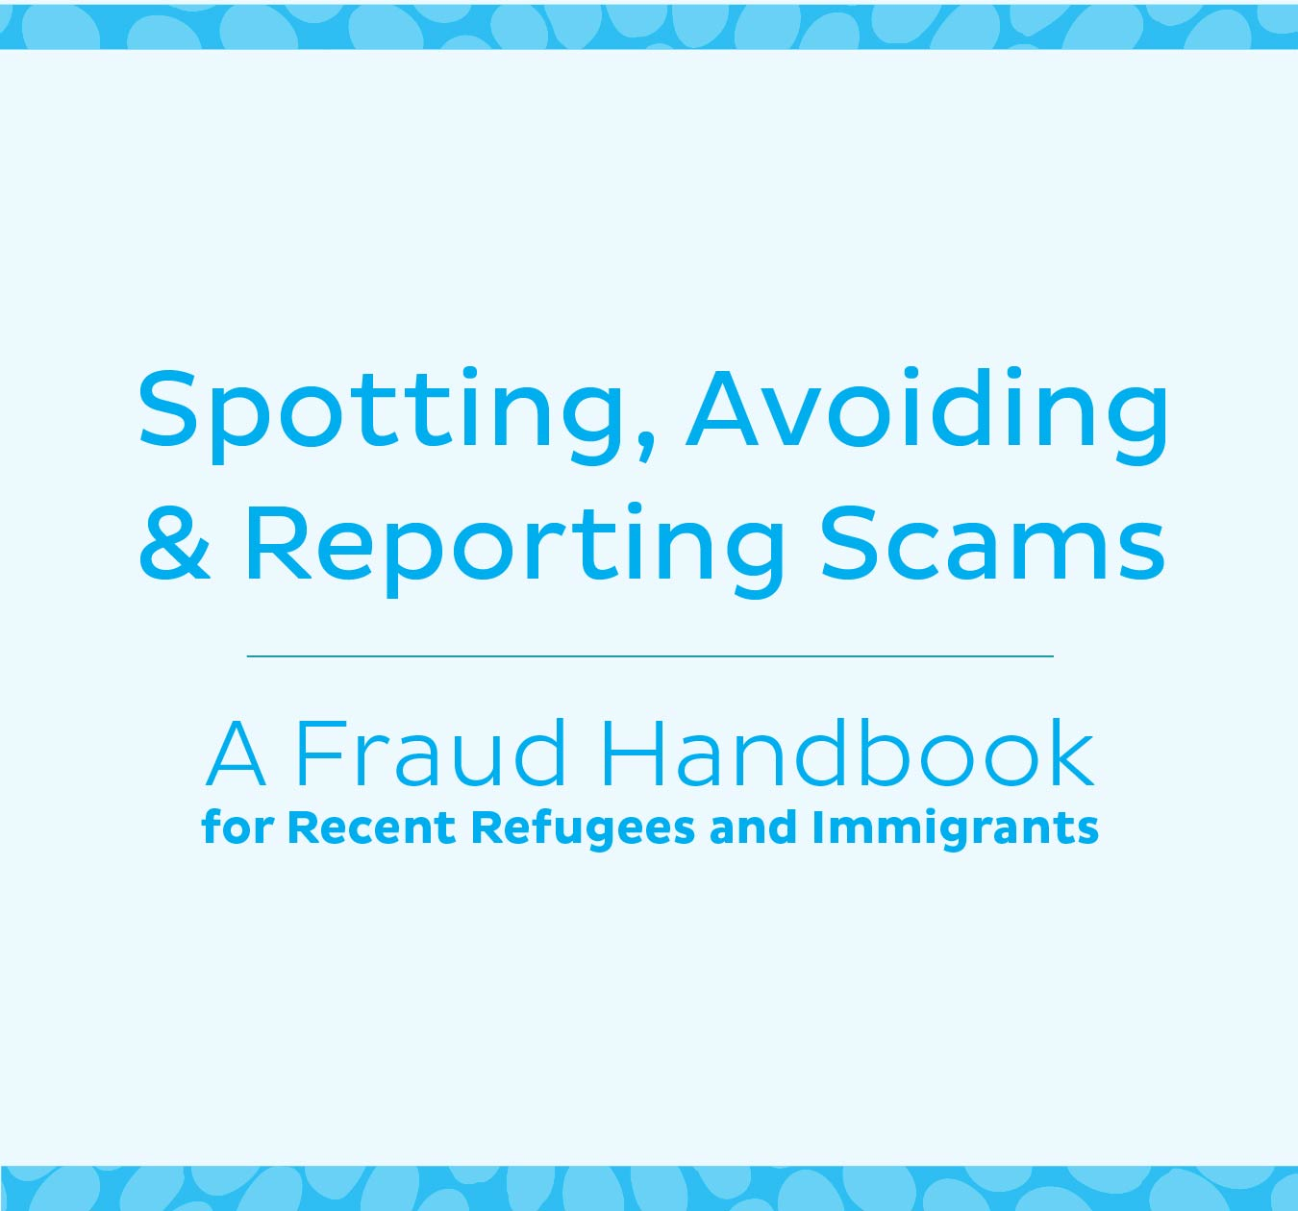
The Federal Trade Commission (FTC) is a government agency that protects people from frauds and scams.
Here are some warning signs of a scam. When you see a warning sign, stop. Talk about it. And report scams to the Federal Trade Commission: ftc.gov/complaint or
1-877-382-4357.

Warning Signs of a Scam

Did someone promise you a job – if you pay them?
Never pay anyone who promises you a job, a certificate that will get you a job, or secret access to jobs. Those are scams.

Did the IRS call saying you owe money?
The IRS never calls to ask for money.

Did someone else from the government call, threatening you and demanding money?
The government doesn’t call to threaten you or ask for money.

Entering the Diversity Visa Lottery to get a Green Card?
It’s free to apply and the choice is random. No one can increase your chance of winning.

Looking for legal help with immigration?
Use a lawyer or an accredited representative, never a notario.

Did you get a call or email saying you won something? Except there’s a fee?
Never pay for a prize. That’s a scam. You’ll lose your money.

Did a caller offer to help you get back some money you lost?
No government agency or legitimate business will call and demand money to help you get money back.

Did you get a check from someone who asked you to give them part of the money back?
Never give someone money in return for a check. Fake checks can look real and fool the bank. You’ll have to pay back all the money.

Did you get an email, text, or call asking for your credit card, bank account, or Social Security number?
Never give that information to anyone who asks over email, text or phone.

Ways to Protect Yourself and Your Information
- Don’t carry all of your important papers or ID cards with you.
- Don’t click on links in emails unless you’re sure you know what it is. Clicking can put bad programs on your device.
- If you’re shopping or applying for a job online, make sure the website starts with https. The ‘s’ means the site is secure.
- If you think someone stole your identity, visit identitytheft.gov for help.
- Sign up for the Do Not Call Registry: donotcall.gov.

