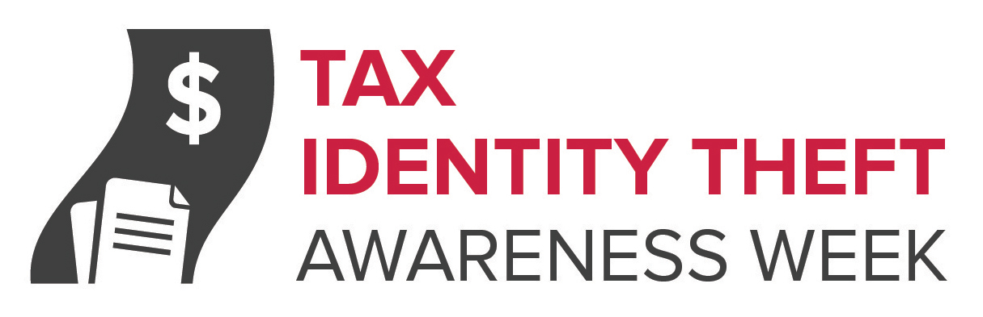DAILY TIPS

Monday

Tax Identity Theft Awareness Week Tip #1: Tax identity theft happens when someone files a fake tax return using your personal information — like your Social Security number — to get a tax refund or a job. This week we’ll post tips to help you lessen the chance you’ll be a victim and learn what to do if you are. The first tip? File early in the tax season — if you can — to get your refund before identity thieves do. When you file, make sure you use a secure internet connection or mail your tax return directly from the post office to make it more difficult for thieves to get their hands on your personal information. Learn more at ftc.gov/taxidtheft and irs.gov/identitytheft.

Tuesday

Tax Identity Theft Awareness Week Tip #2: What should you do if you think your Social Security number has been stolen? Or if you get a letter from the IRS saying more than one tax return was filed in your name, or that IRS records show wages from an employer you don’t know? Call the IRS Identity Theft Protection Specialized Unit at 1-800-908-4490. Report the fraud and ask for IRS ID Theft Affidavit Form 14039. If you are a tax identity theft victim, the IRS may give you a personal PIN number to verify your identity and protect your file going forward. Learn more at ftc.gov/taxidtheft and irs.gov/identitytheft.

Wednesday

Tax Identity Theft Awareness Week Tip #3: Have you heard about IRS imposters? Tax scammers posing as the IRS call and say you owe taxes, and threaten to arrest you if you don’t pay right away. They might know all or part of your Social Security number, and they can rig caller ID to make it look like the IRS is calling. Before you can investigate, they tell you to put the money on a prepaid debit card and tell them the card number. The IRS won’t ask you to pay with prepaid debit cards or wire transfers, and won’t ask for a credit card number over the phone. If the IRS needs to contact you, they will first do it by mail. If you have any doubts, call the IRS directly. Learn more at ftc.gov/taxidtheft and irs.gov/identitytheft.

Thursday

Tax Identity Theft Awareness Week Tip #4: Here are some other tips to lessen the chance you’ll be a victim of tax identity theft:
- Always protect your Social Security number or Medicare card number: don’t give it out unless you have to, and always ask why it’s needed, how it’s going to be used, and how it will be stored.
- Shred old taxes returns you’re no longer required to keep, as well as draft returns, extra copies, and calculation sheets.
- Ask for recommendations and research tax preparers before you turn your personal information over to them.

Friday

Tax Identity Theft Awareness Week Tip #5: Once tax identity thieves have your Social Security number and personal information, they can use them to commit other forms of identity theft, such as opening new financial accounts in your name. For steps you can take to deal with identity theft, go to ftc.gov/idtheft. Also remember to check your credit report annually. It’s free at annualcreditreport.com.

